Wild West Days Parade
Sunday, August 16, 2026-High Noon (12 pm)
Lineup – Vernon County Fairgrounds
Parade Theme – Western
Contact Person:________________________________________________________
Phone:_______________________ Address_________________________________
City:______________________State_______________ Zip code:________________
Email:________________________________
Will you have Music: YES No (circle one)
Unit Name: (business, organization, etc.)

Business, Club/Organization, Royalty, Marching Band, Horse Unit, Political
(circle one)
________________________________________________________________________________________________________________________________________________________________________________________________________________________________________________________________________________________________________________________________________________________________________
Please send applications to:
Lori Dickman at loridickman0813@gmail.com
Cheryl Arneson at cherylarneson@ymail.com
Lineup will be at Vernon County Fairgrounds – numbers assigned day of parade. Check in with parade coordinators.
Wild West Days Festival and Volunteers assume no liability for accidents/injuries. You assume responsibility for participation for this event.
Thank you for joining us!

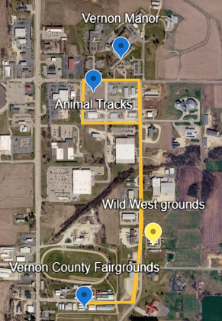
The parade will start at the Vernon County Fairgrounds, proceed North on Nelson Parkway, turn left on Cty BB, left on Power Drive at Animal Tracks and return to Nelson Parkway and return to Vernon County Fairgrounds.

